|  |
| --- |
| Problem statement: 1 |
| Develop programs using ArrayList, HashMap, HashSet. & Use Iterator for iterating Collections. |
| Problem Statement 1:  1. Develop a java class with a method ***storeEvenNumbers(int N)*** using ArrayList to store even numbers from 2 to N, where N is a integer which is passed as a parameter to the method ***storeEvenNumbers().*** The method should return the ArrayList (A1) created. 2. In the same class create a method **printEvenNumbers()**which iterates through the arrayList A1 in step 1, and It should multiply each number with 2 and display it in format 4,8,12….2*N. and add these numbers in a new ArrayList (A2). Thenew ArrayList (A2) created needs to be returned. 3. Create a method ***retrieveEvenNumber(int N)***  parameter is a number N. This method should search the arrayList (A1) for the existence of the number ‘N’ passed. If exists it should return the Number else return zero.   **Hint:**  Use instance variable for storing the ArrayList A1 and A2.  **NOTE:** You can test the methods using a main method. Problem Statement 2:  1. Develop a java class with a instance variable ***Country*** HashSet (H1) add a method **storeCountryNames(String CountryName)** , the method should add the passed country to a HashSet (H1) and return the added HashSet(H1). 2. Develop a method ***retrieveCountry(String CountryName)*** which iterates through the ***HashSet*** and returns the country if exist else return null.   **NOTE:** You can test the methods using a main method. Problem Statement 3:  1. Develop a java class with a instance variable ***CountryMap*** HashMap (M1) add a method **storeCountryCapital(String CountryName, String capital)** , the method should add the passed country and capital as key/value in the map M1 and return the Map (M1).  |  |  | | --- | --- | | Key- Country | Value - Capital | | India | Delhi | | Japan | Tokyo |  1. Develop a method ***retrieveCapital(String CountryName)*** which returns the capital for the country passed from the Map M1 created in step 1. 2. Develop a method ***retrieveCountry(String capitalName)*** which returns the country for the capital name passed from the Map M1 created in step 1. 3. Develop a method which iterates through the map M1 and creates another map M2 with Capital as the key and value as Country and returns the Map M2.  |  |  | | --- | --- | | Key - Capital | Value – Country | | Delhi | India | | Tokyo | Japan |  1. Develop a method which iterates through the map M1 and creates a ArrayList with all the Country names stored as keys. This method should return the ArrayList.   **NOTE:** You can test the methods using a main method. |

### Problem Statement 2:











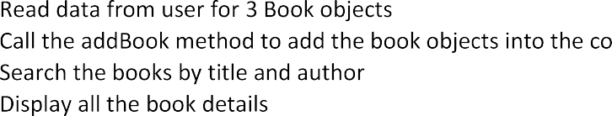

**Add on:**

[ bookid must be number.

Create a java class which will use a random number generator, and that value should be your id value.]

**After 4 no. point:**

5.Develop a utility method which will find the book to be published in a journal, to implement that add instance variable published, datatype - Boolean.

6.Create an array of 5 books then, Convert the array to a treeset object and use iterator to print them.